The Minibeast Quiz

- What are the main differences between millipedes and centipedes? ______________________________________
________________________________________________
________________________________________________

- What is a ‘habitat’? _________________________________
________________________________________________

- Name some good habitats for minibeasts? ________________
________________________________________________

- How many legs does an arachnid have?
Please circle: 2 6 8

- How many legs does an insect have? _____________________

- What is special about a pill woodlouse? __________________
________________________________________________

- How many legs does an adult woodlouse have? _____________

- Name some different types of protection that some minibeasts have? ___________________________________________
________________________________________________

- Name a minibeast that is a herbivore? ___________________

- Where do beetles keep their wings? ____________________
________________________________________________

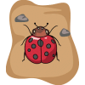 |  | 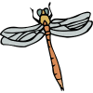
 |  |  | 

